PROJECT REPORT

Project Summary
This project focuses on analyzing Flipkart sales and related business data to identify sales performance, customer behavior, product returns, cancellations, and potential opportunities for improving business profitability. The main objective of the analysis was to transform raw business reports into meaningful insights that could help the client understand the factors affecting sales and identify areas for improvement.
The analysis used multiple datasets, including Sales, Returns, Cancellations, Earn More, and Search Traffic reports. The raw datasets were first cleaned and structured using Python and Pandas. Unnecessary columns, missing values, duplicate records, inconsistent product identifiers, and data-type issues were addressed to improve data quality and ensure reliable analysis.
After data preparation, the cleaned datasets were imported into a PostgreSQL database, where SQL was used for detailed exploratory and business analysis. Key metrics such as total revenue, sales performance, discount impact, customer ordering patterns, return rates, return reasons, cancellation patterns, and revenue affected by returns and cancellations were investigated. The Search Traffic and Earn More datasets were additionally analyzed to identify customer demand, potential sales opportunities, and areas where the business could improve its earnings.
The final insights were intended to move beyond simply describing past performance and provide actionable recommendations for the client. These included identifying products with high return rates, understanding the major reasons for returns and cancellations, identifying products with strong customer demand, and highlighting opportunities to improve product visibility, pricing, promotions, and overall profitability.
The project followed an end-to-end data analytics workflow consisting of data cleaning and preparation in Python, data storage and analysis using PostgreSQL, and data visualization and reporting using Microsoft Power BI. This approach provided a structured process for converting raw transactional data into business-oriented insights and recommendations.
Dataset Summary
The project used multiple business reports provided by the client to analyze sales performance, customer behavior, product returns, cancellations, customer demand, and earning opportunities. The main datasets used in the analysis were:
1. Sales Report
The Sales Report was the primary dataset used to analyze overall sales performance. It contained information about orders, products, SKUs, order dates, pricing, discounts, seller share, invoice amounts, customer locations, fulfilment details, and order types. After cleaning, the dataset was used to calculate key sales metrics and identify trends in product performance, customer purchasing behavior, discounts, and revenue.
2. Returns Report
The Returns Report contained information about returned products, including return dates, product categories, SKUs, return amounts, return reasons, and sub-reasons. This dataset was mainly used to understand the scale and causes of product returns. The analysis identified frequently returned products, major return reasons, and the financial value associated with returned products.
3. Cancellation Report
The Cancellation Report was used to investigate cancelled orders and identify the factors contributing to cancellations. The dataset provided information that helped analyze cancellation patterns, affected products, and cancellation reasons. This analysis supported the identification of potential areas where cancellations could be reduced.
4. Search Traffic Report
The Search Traffic Report was used to understand customer demand and product visibility. It provided information about customer searches and product traffic on the platform. The dataset was analyzed to identify products attracting customer interest and potential opportunities where high customer demand could be converted into additional sales.
5. Earn More Report
The Earn More Report was used to identify opportunities for improving seller earnings and product performance. It provided additional information that could be used to evaluate products and identify potential opportunities related to pricing, promotions, visibility, and sales growth.
Dataset Integration
The datasets were initially provided as separate CSV files and were cleaned and structured before analysis. The Sales, Returns, and Cancellations datasets were imported into the same PostgreSQL database to allow related analyses. Inconsistent SKU formats between the Sales and Returns reports were standardized using a cleaned SKU identifier to enable reliable product-level comparisons.
The Search Traffic and Earn More reports covered a broader period than the May sales data and were therefore used primarily for general business and opportunity analysis rather than direct May-to-May comparisons.
Exploratory Data Analysis Using Python
Initial exploratory data analysis was performed using Python in Jupyter Notebook, primarily using the Pandas and NumPy libraries. The purpose of this stage was to understand the structure and quality of the raw datasets before performing detailed analysis in PostgreSQL.
The main activities included:
- Loading the different CSV datasets into Python and examining their structure, columns, and data types.
- Identifying and removing unnecessary or redundant columns that were not relevant to the business analysis.
- Checking for missing values and determining whether they required treatment or could be removed based on their relevance.
- Identifying duplicate records and removing exact duplicates where appropriate.
- Checking numerical columns for unusual or negative values and investigating whether they represented valid business transactions or data inconsistencies.
- Converting date columns into appropriate datetime formats and creating additional date-related fields such as year, month, day, and weekday.
- Standardizing inconsistent product identifiers, particularly SKU values, to make the datasets easier to compare and integrate.(done in postgre)
- Reviewing the cleaned datasets using descriptive statistics and basic data inspection to ensure that the data was suitable for further analysis.
After the initial cleaning and exploration, the prepared datasets were exported as cleaned CSV files and subsequently imported into PostgreSQL for more detailed SQL-based analysis.
Business Analyses using POSTGRE SQL
KPI’s were analyzed, and valuable insights were gained.
- Total revenue for the month of May
160717
- Total orders for May
137
- Average order value for the month
1173.11
- Highest order value(costly product)
1916
PRODUCT PERFORMANCE
- Top product by revenue
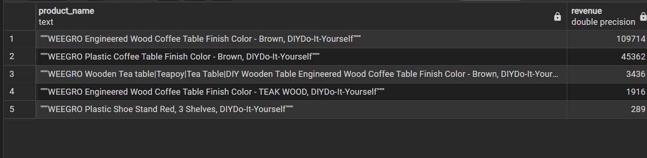
- No of products orders per product
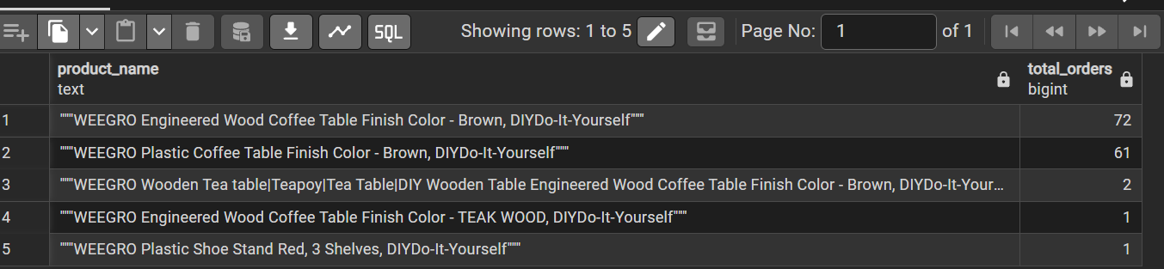
We can see that even based on orders wood coffee table brown color performed good,it’s the successful product
State wise analysis
- By Revenue
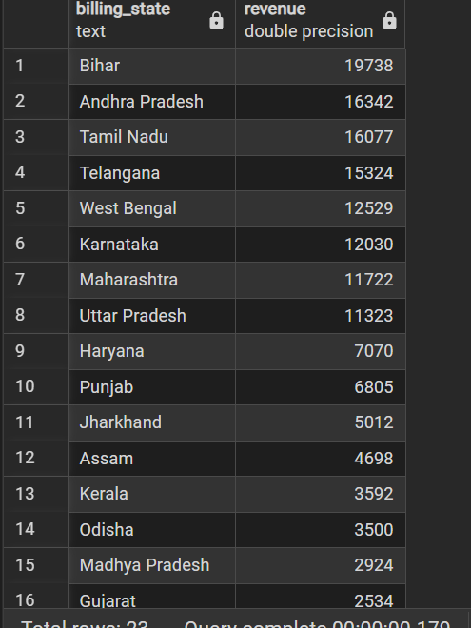
- By Orders
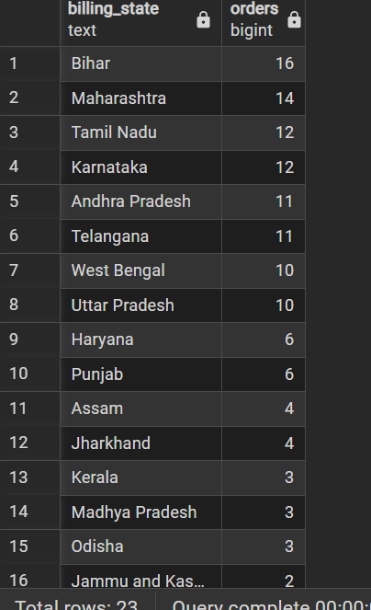
Both proves that bihar contributed to the most of the orders and generate more income
Trend
- Which day customer placed more orders
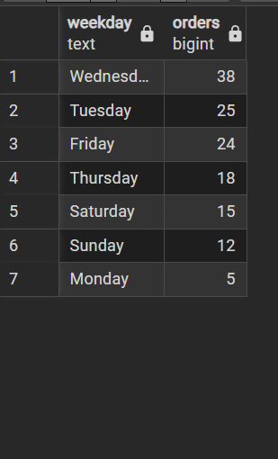
So Wednesday more revenue? YES(may)
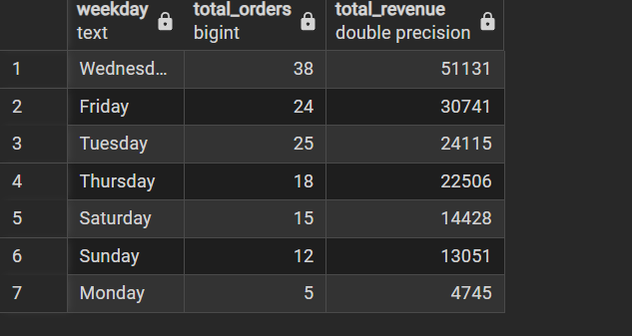
Wednesday orders are more (stock updation recommended)
DISCOUNT ANALYSIS

- More revenue on discount?
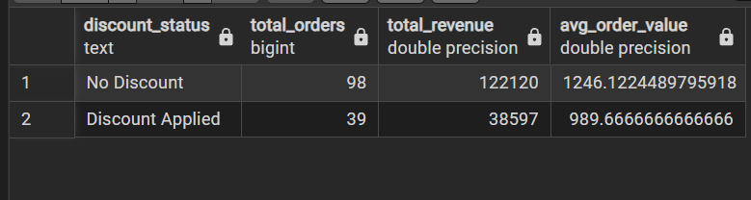
- Product with high discount?
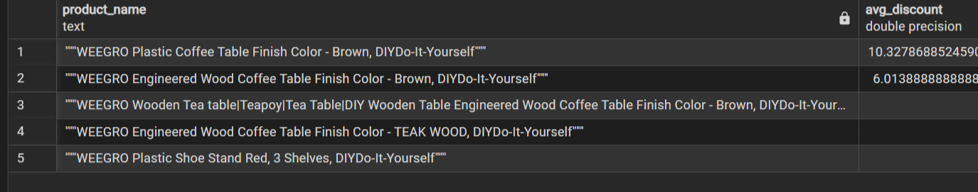
Even if the discount is not applied we can see that products performed well.
- Orders from shopsy
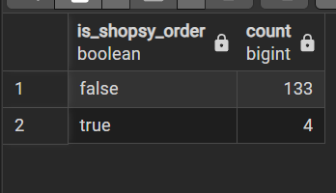
PAYMENT ANALYSIS
- Which payment method is preferred?
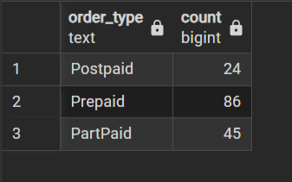
CUSTOMER DISTRIBUTION
- States with most customer?
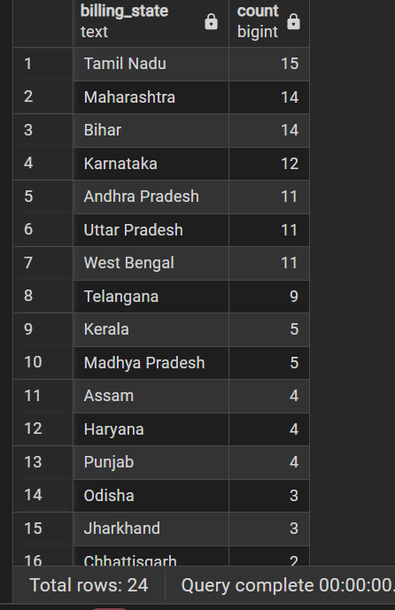
- Customer by revenue?

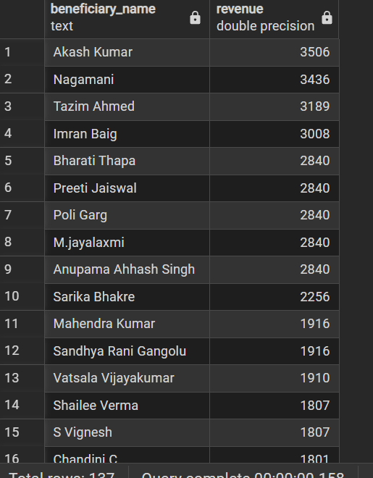
- Do we have repeated customers? YES we can see these people ordered more than once.meaning they are satisfied
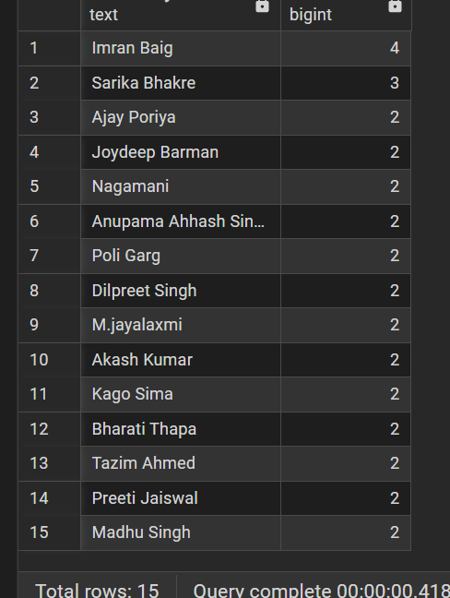
RETURN ANALYSIS
- No. of returns :7
- Return percentage :5.11
- No. of cancels:15
- Cancel percentage: 10.95
- Breakdown:
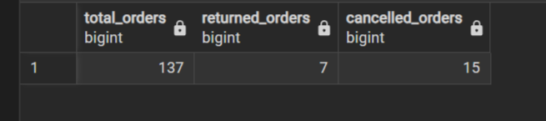
Meaning more no. of people rejects the order before they even see it.
- Return Reason
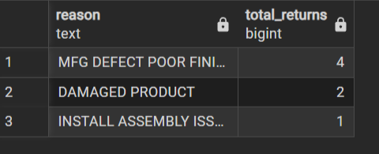
- Return sub reason
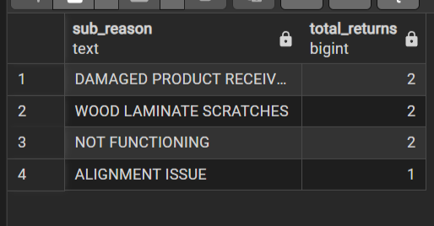
- Contribution
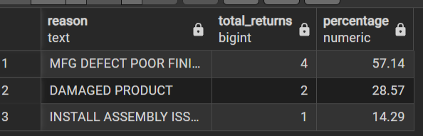
Returns could mainly be due to quality issue
- Cancel reason
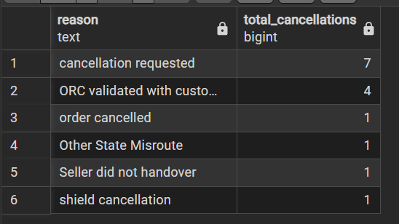
- Cancel Sub reason:
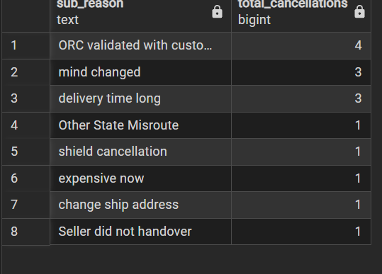
- Contribution:
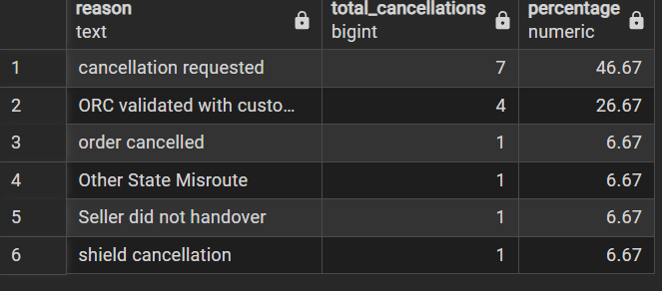
- Product with highest returns?
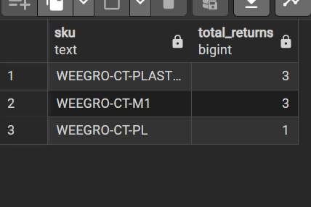
Quality of plastic table have to be verified since previously we saw return is mainly due to quality issue
- Product with highest cancels?
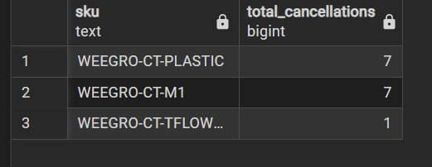
Plastic teapoy was also cancelled the most but this could more likely be done at seller end
- Total breakdown:
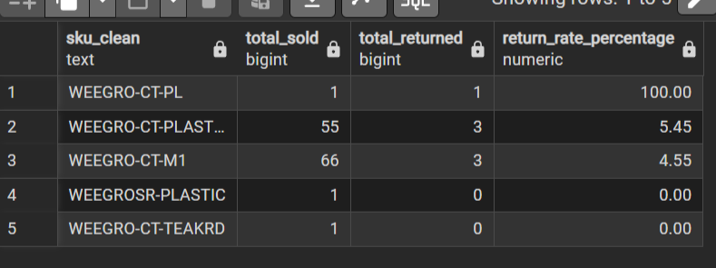
- Revenue lost by returns 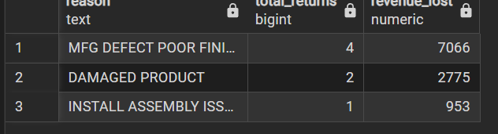
- Revenue lost by cancels
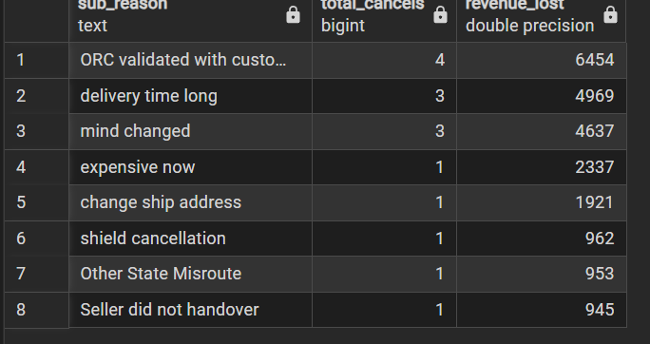
Revenue lost by returns are more even if there are less returns than cancels proving that returns are more costly than cancels
FINDING INSIGHTS:
- Product with highest views
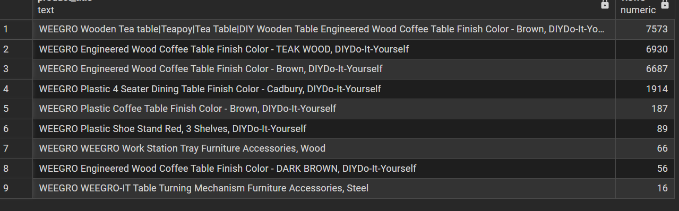
- Most Clicked
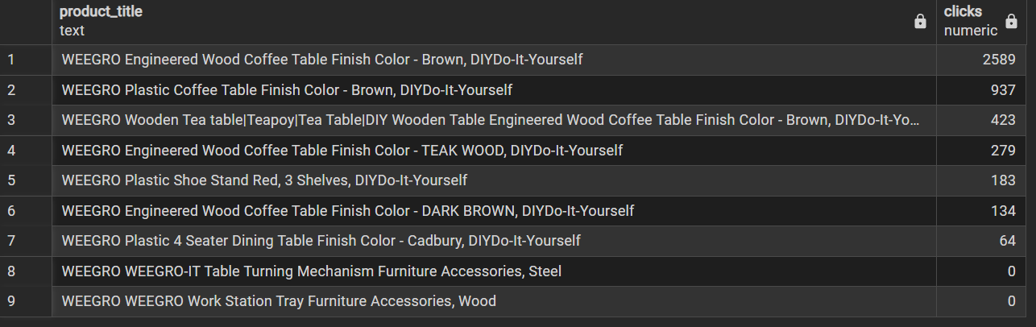
Weegro engineered wood coffee table brown has good label and cateloging as most of the people after viewing clicks to see further. But products like teak wood are not good enough for viewers to click and view further.
- Highest revenue from search
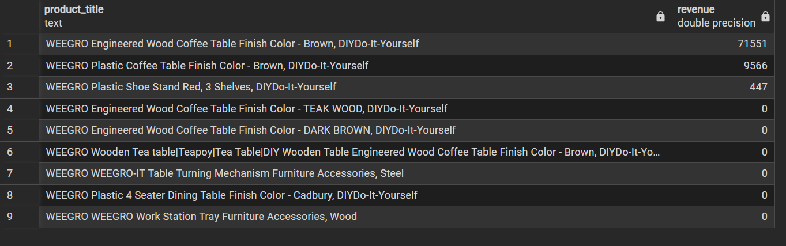
- Highest Conversion rate
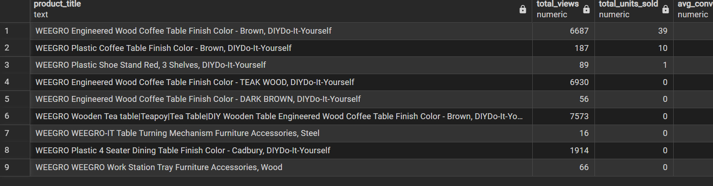
- Click through rate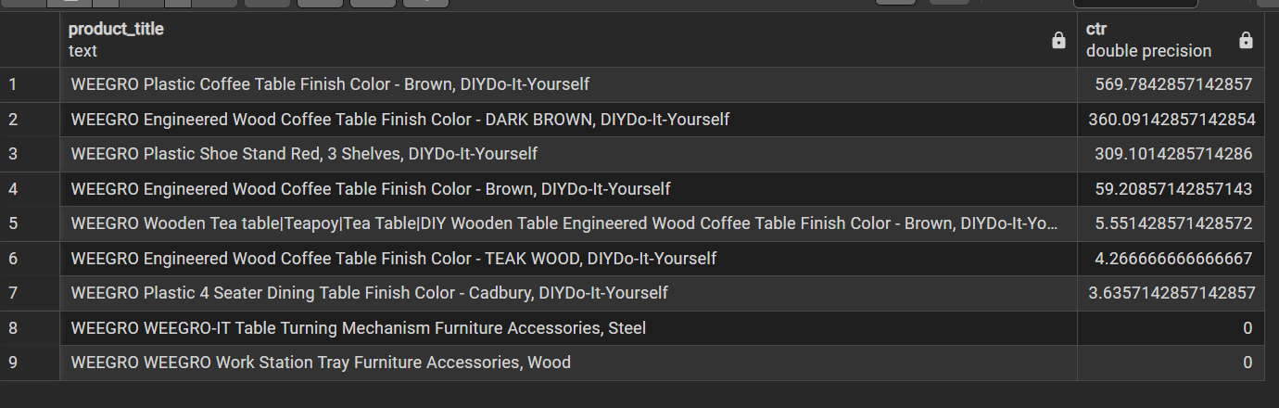
- Products having high visibility poor conversion:
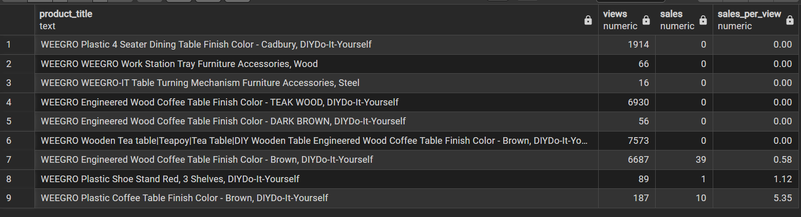
4 seater dining table had 1914 views but failed to make even a single sale.
BUSINESS RECOMMENDATION:
It is recommended to maintain full stock on Wednesday, as there is a high possibility of receiving more orders. Even without discounts, customers tend to buy the product, indicating that they are willing to pay more if the quality is good. The primary reason for product returns is manufacturing defects, so improving quality to some degree could help reduce returns. While most products receive views, they are not convincing enough for customers to select and purchase. Therefore, product cataloging should be enhanced by providing accurate dimensions and high-quality images. This observation is based on the trends observed in May; further conclusions can be drawn after analyzing data from the past couple of months. Currently, the data is inadequate for making firm conclusions.

